**Assignment 4**

**Question 1**

**Implement deletion operation from the end of the linked list and Insertion operation from the beginning of the linked** l**ist**

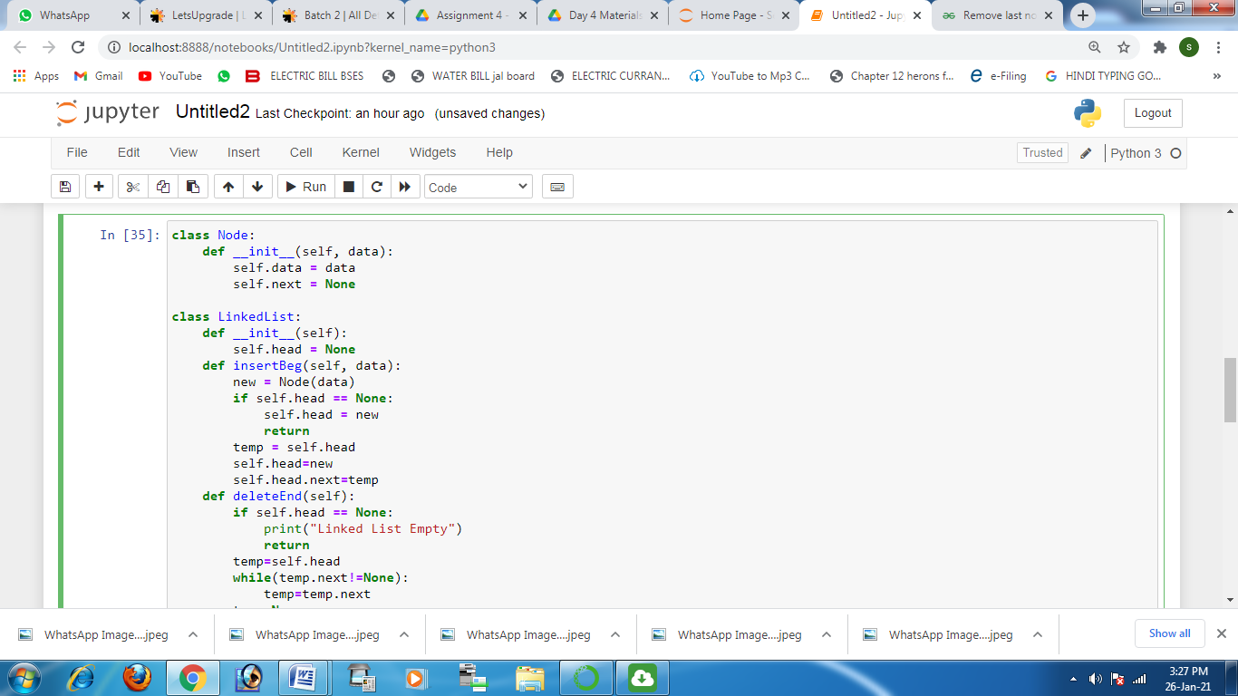

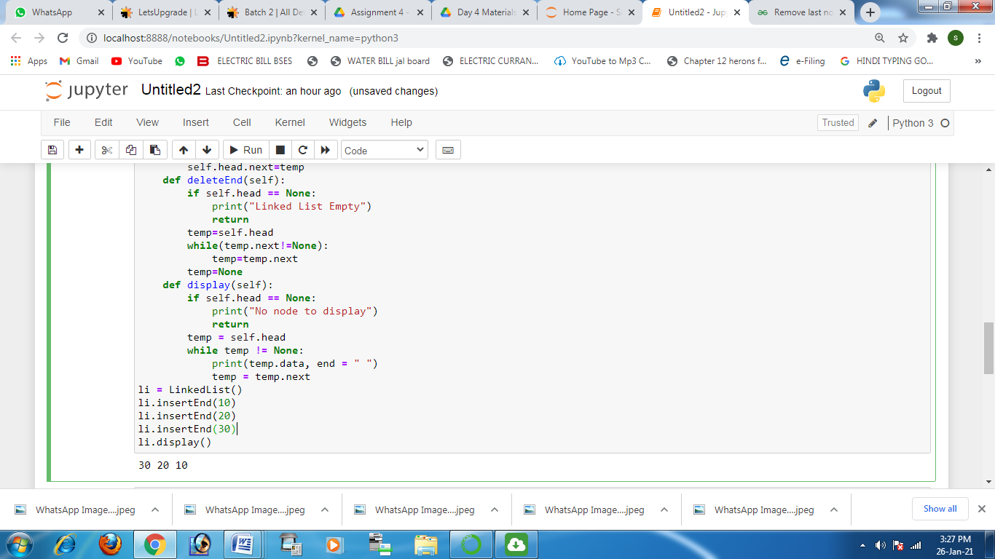

**Question 2**

**Implement binary search using python language.**

**(Write a function which returns the index of x in given array arr if present, else returns -1)**

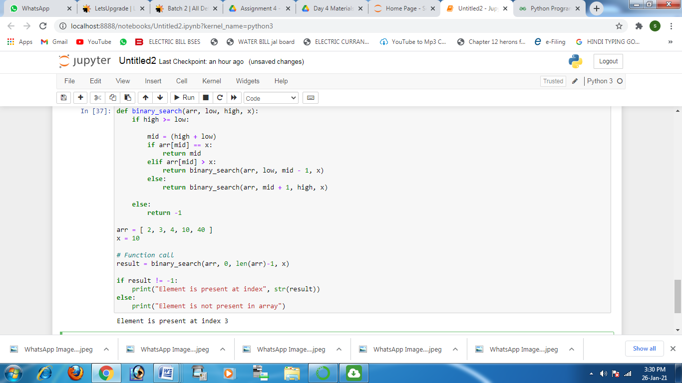

**Question 3 Write a Python program to find the middle of a linked list.**

